**NAME: PRAKHAR MISHRA**

**DATE: 24/01/2024**

**QUESTIONS**

1. **Demonstration of RANK(), OVER () statement.**

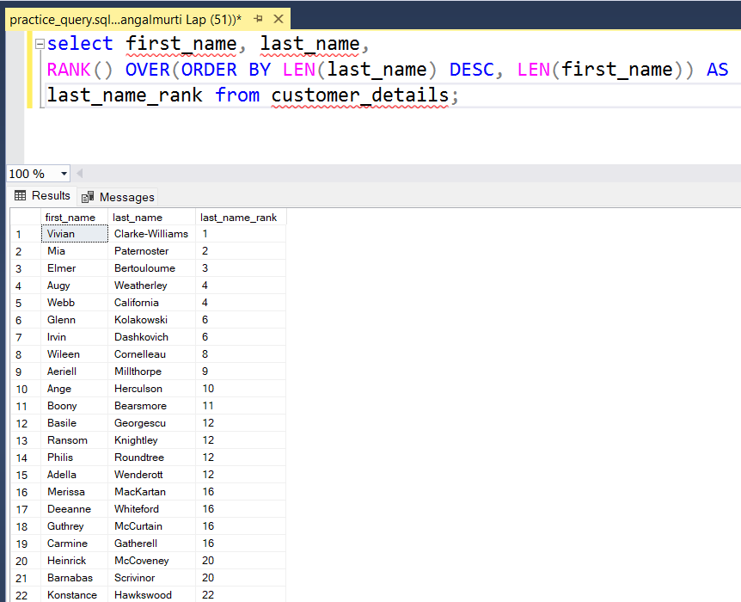

1. **Demonstration of REGEX().**

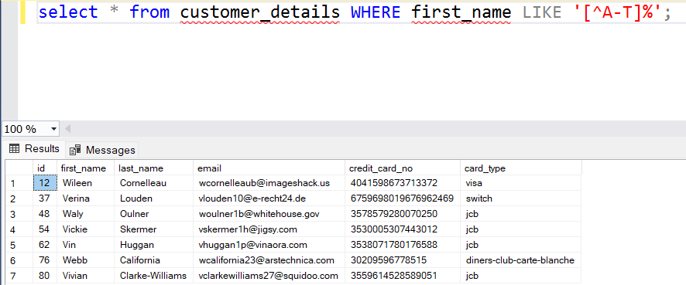

1. **Aggregation Function.**

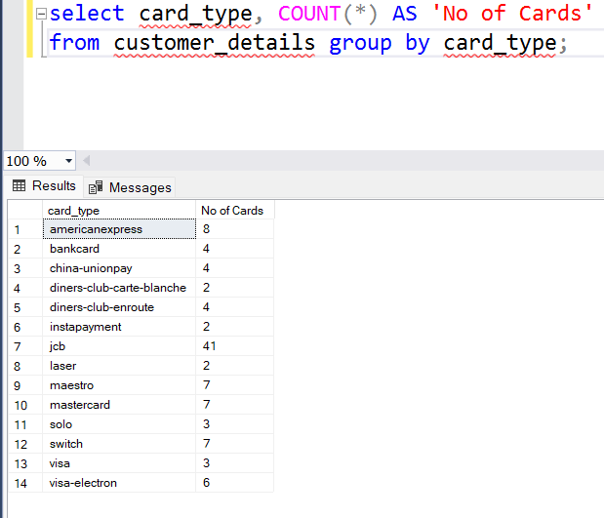

1. **Demonstration of WITH().**

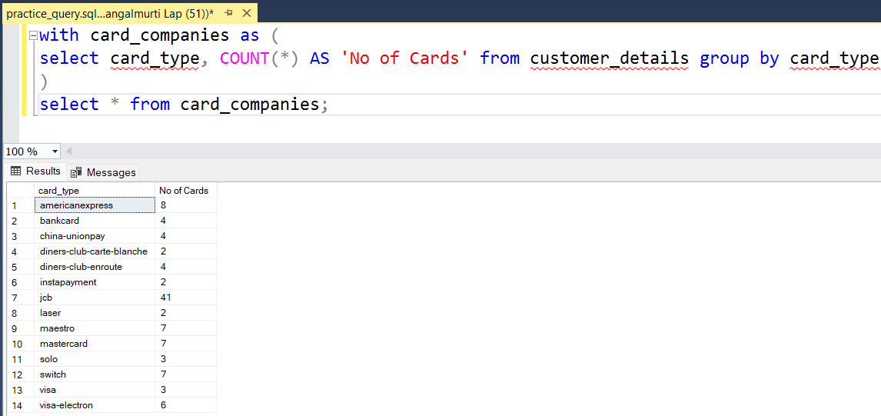

1. **Demonstration of aggregate, rank(), over().**

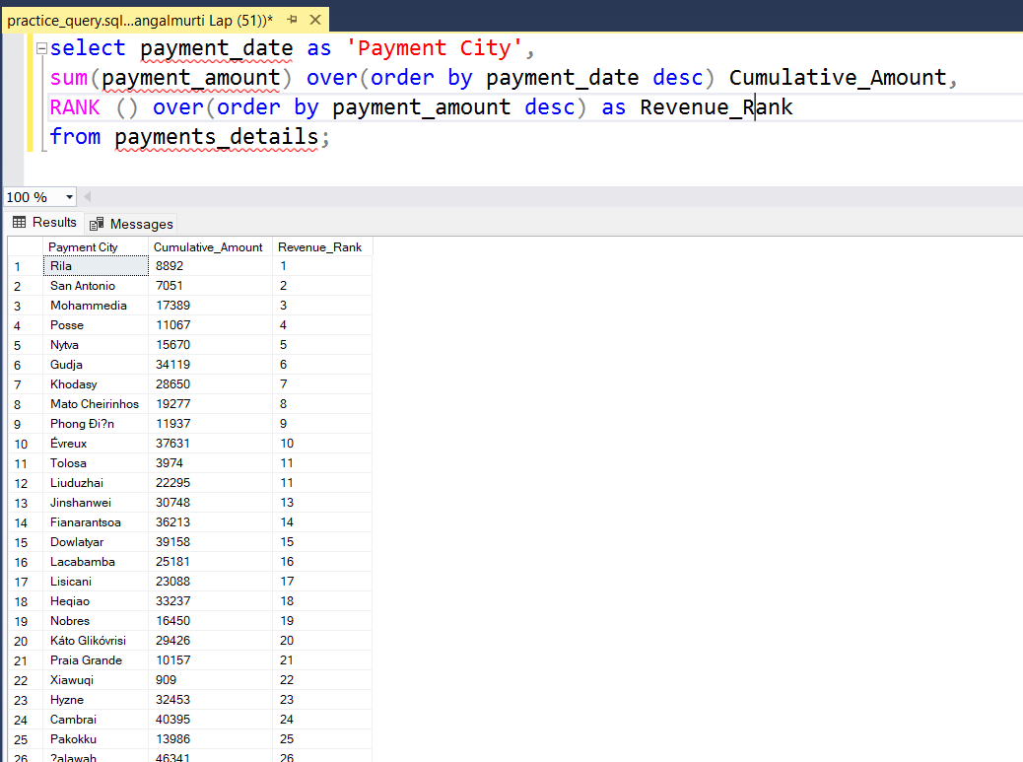

1. **Demonstration of PARTITION(), OVER() and Aggregation.**

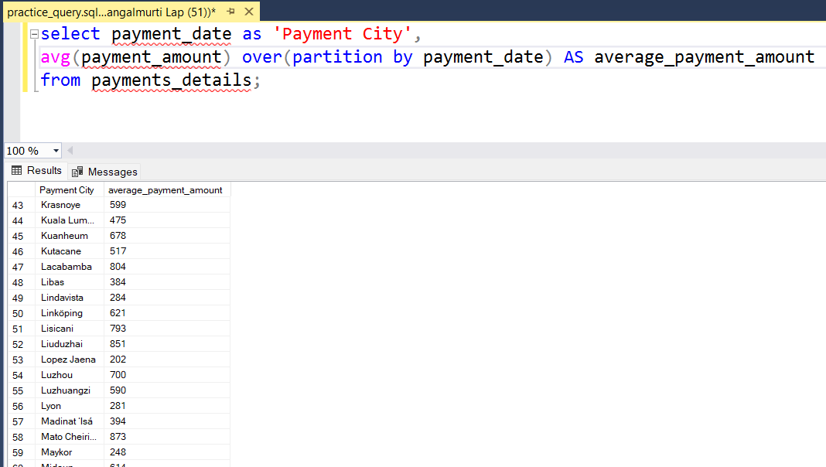

1. **Demonstration of View.**

